**Last Rebort**

**Creat OS Project**

**Team work :**

Sara Alzamly : - Create the Websit

- Download vmware and upuntu

- Writing reports

- Writing a task table

- Apply the code to the dummy environment

Haneen Tabasi: - Create a trello

Code analysis-

Creat social media-

- Writing reports

- Writing a task table

**: About the project**

The idea of making a simple operating system started from our study of the operating system course to embody the concepts that we study in the course by making bootloder, kearnel, application, and linking application with kearnel

**Summary of steps :**

The Start 1.

Publish the site, creat social media ,creat Task Table, creat Trello, creat Virtulization , order of ideas

2.Make boot loder

Create a fake environment, write the potloader code in assimbly language for 16 bits and our compiler using nasm and our run through qemu

3.make kernel

First you need the multi-boot bootloader file which directs the GRUB to download it.

Then:

1 install tools requirements

### 2 Write the following file codes boot.s ,linker.ld ,grub.cfg ,kernel.c ,kernel.h ,run.sh And run it through qemu.

4.Application

### Our calculator app will be (add, subtract, multiply, divide,moduler)

We create a desktop folder called calculator and add the following documents: boot.s ,linker.ld ,grub.cfg ,kernel.c ,kernel.h ,run.sh , Keyboard.h, Char.h , Char.c , Types.h , utils.c, utils.h And run it through qemu.

5.Running & Testing the OS

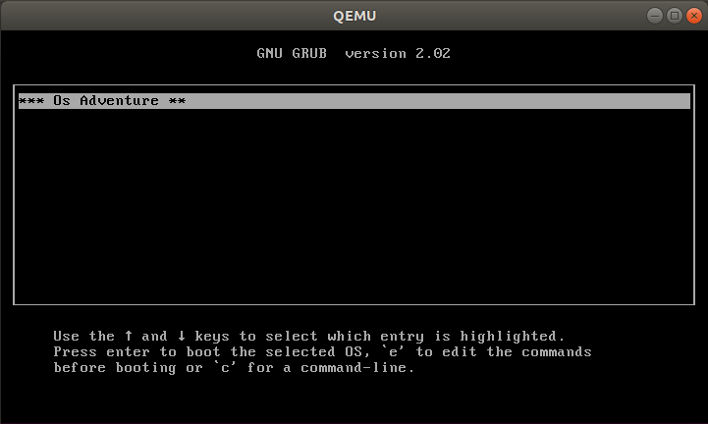

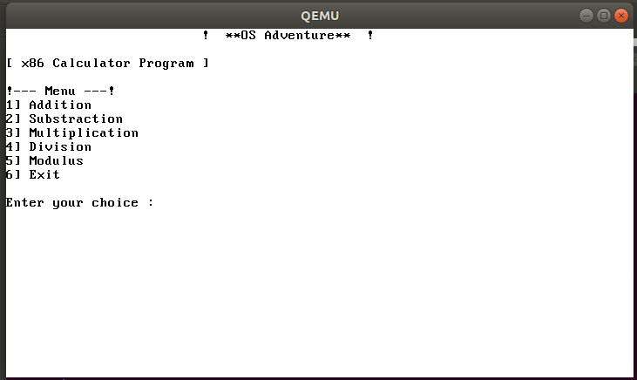

: **Challenges**

1-start the wrong way its resources were not available online and not alert us it's ineffective rom the admin

Our lack of experience 2-

3-Our lack of training

restricting creativity 4-

5-Lack of online search skill

6-Difficulty dealing with linux system at first

7-Not understanding the language of assembly

**acquired skills :**

1-Dealing with difference of opinion

2-Increased harmony among team members

Dealing with the Ubuntu 3-

4-work under pressure

5-Search online